**EXPERIMENT 3**

**Aim :**

Write a program to Add 16-bit Numbers.

**Requirements :**

8085 Simulator IDE Software.

**Procedure :**

1. Go to the tools and select assembler. Write the code in assembler window.
2. Go to the tools and select assemble & load in assembler window or press F8.
3. Check for errors and fix them.
4. Go to 8085 Simulator IDE and open simulation and start or press F1.
5. Open memory editor from tools option. Enter the 1st value at the memory location defined by LHLD.
6. Again open simulation and start or press F1.
7. Open memory editor from tools option. Enter the 2nd value at the memory location defined by LHLD.
8. Again open simulation and start or press F1.
9. Again open memory editor to observe the final result.

**Program to Add 16-bit Numbers :**

|  |  |  |  |
| --- | --- | --- | --- |
| **Address** | **Mnemonics** | **Operands** | **Comments** |
| 0000H | MVI C | 00H | Initialize register C with 00H to store carry |
| 0002H | LHLD | 0050H | Load H-L pair with 1st value from memory location 0050H |
| 0005H | XCHG |  | Exchange contents of H-L pair with D-E pair |
| 0006H | LHLD | 0060H | Load H-L pair with 2nd value from memory location 0060H |
| 0009H | DAD D |  | Add register pair D-E with H-L & store the result in H-L |
| 000AH | JNC | 000EH | If carry is present , go to next step else go to 000EH |
| 000DH | INR C |  | Increment register C by 1 |
| 000EH | SHLD | 0070H | Store the value of H-L pair at memory location 0070H |
| 0011H | MOV A , C |  | Move the content of register C to Accumulator |
| 0012H | STA | 0080H | Store the value of Accumulator at memory location 0080H |
| 0015H | HLT |  | End of program |

**Screenshots :**

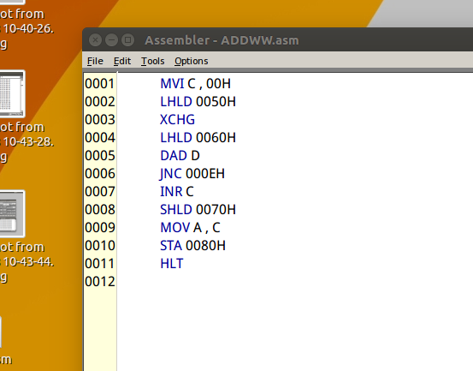 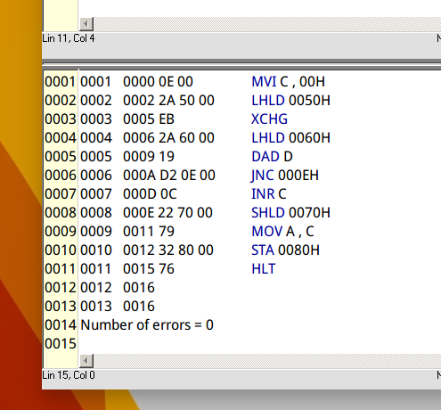

**Output :**

|  |  |
| --- | --- |
| **Before Execution** | **After Execution** |
| **1st value (at 0050H) :**   |  |  | | --- | --- | | **H** | **L** | | **9BH** | **7EH** |   **2nd value (at 0060H) :**   |  |  | | --- | --- | | **H** | **L** | | **FBH** | **B9H** | | |  |  |  |  |  | | --- | --- | --- | --- | --- | | **Result of Addition**  **(at 0070H)** | |  |  | | --- | --- | | **97H**  **(0071H)** | **37H**  **(0070H)** | |  | | **Carry**  **(at 0080H)** | |  |  | | --- | --- | | **00H**  **(0081H)** | **01H**  **(0080H)** | | |

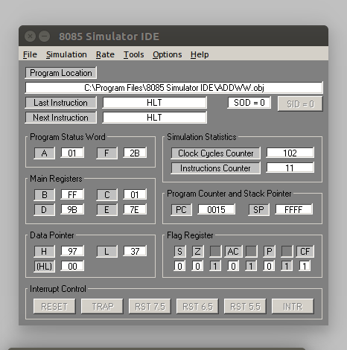

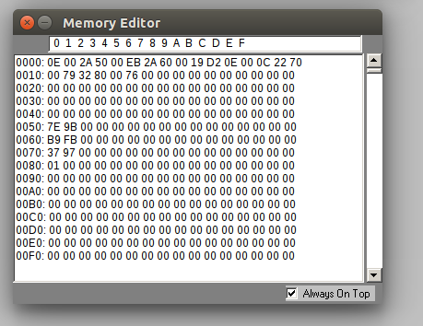

**Flow Chart :**

**Yes**

**No**

**Result :**

Program to Add 16-bit Numbers was implemented successfully.